**CSIS6033_Lab1_Yibo_Zhu (Ubuntu)**

**CWE-119**

In codes, user can select an item from the list, when the out-of-bounds index (for example 5) was selected, the error-improper restriction of operations within the bounds of a memory buffer (CWE-119) was triggered.

**CWE-125**

This code retrieves a value from an array at a specific array index location that is given as an input parameter to the method.



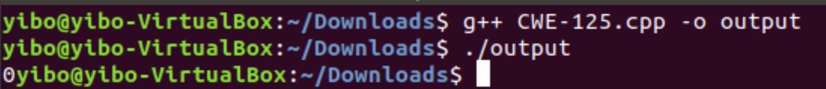



Input -1, output 0. When index is out-of-bound, it read the value before the beginning of the intended buffer.



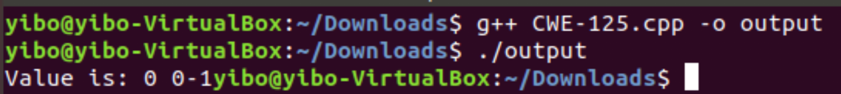



Input 200, output 0 0 -1. When the index is out-of-bound, the codes still try to read element past the end. So, error-out-of-bounds read (CWE-125) was triggered.

**CWE-416**

The codes use already deleted memory pointer ptr to change recent pointer (ptr2)’s value. It triggers the error-use after free (CWE-416).

**CWE-787**

The codes create an array with size 3, but use array[3] = 4 to initialize the array, which triggered out-of-bounds write (CWE-787).

**CWE-476**

This is a single linked list code, in which use “current” pointer to point elements. In the “findNumberInLinkedList” function, if current -> value != target_number, current = current -> next. If the target_number is not in the linked list, current will be a NULL pointer and current -> value will trigger NULL pointer dereference (CWE-476).

**CWE-502**



The codes deserialize an untrusted command without verification (CWE-502). The command will open an unknown webpage (I use aum.edu for example) when the codes run.

Reference for CWE-502:

<https://docs.python.org/3/library/pickle.html>